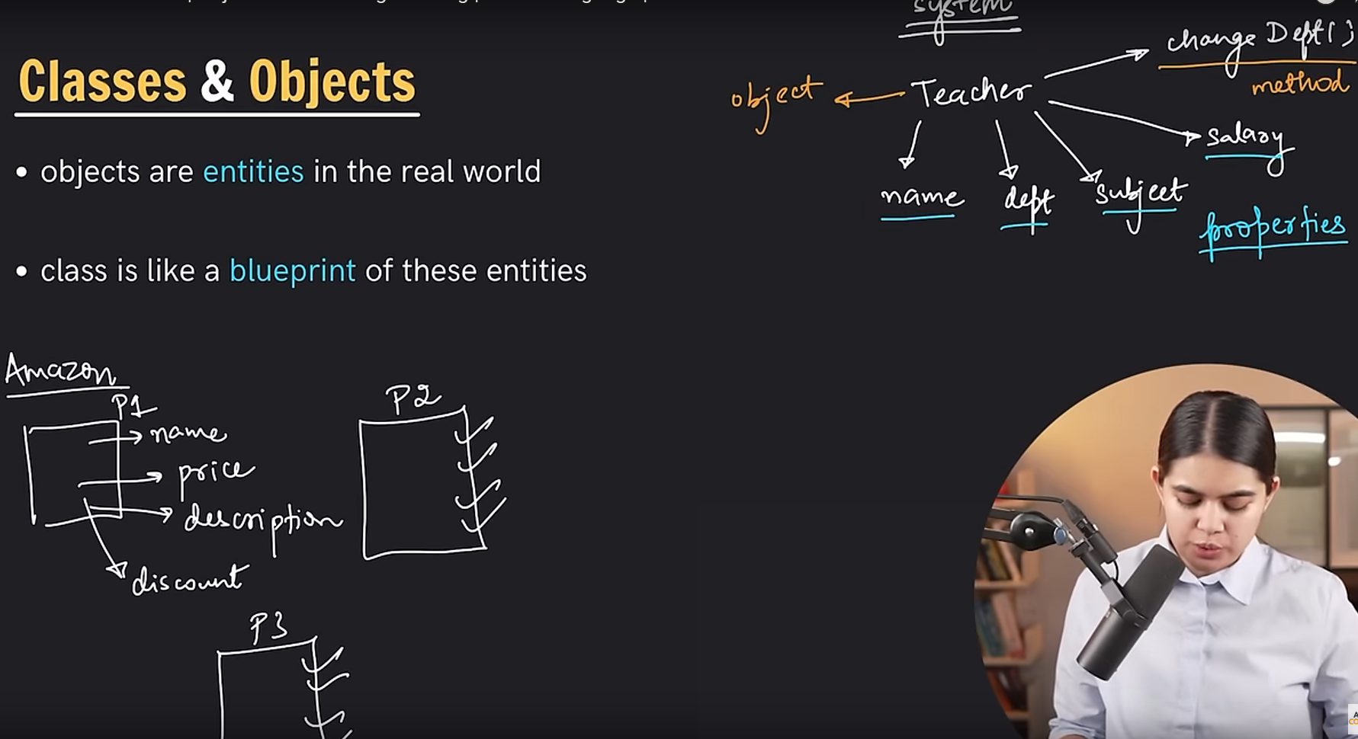

**Code:**

#include <bits/stdc++.h>

using namespace std;

class Employe{

//properties OR Attribute

private:

double salary;

public:

string name, dept, city;

void changedept(string depart){

dept = depart;

}

//setter

void setSalary(double newsalary){

salary = newsalary;

}

//getter

double getSalary(){

return salary;

}

};

int main()

{

Employe e1;

e1.name="Sayed Nahid";

e1.dept="CSE";

e1.city="Dhaka";

cout << e1.name << endl;

cout << e1.dept << endl;

e1.changedept("EEE");

cout << e1.dept << endl;

e1.setSalary(20000);

cout << e1.getSalary() << endl;

return 0;

}

**Encapsulation:**

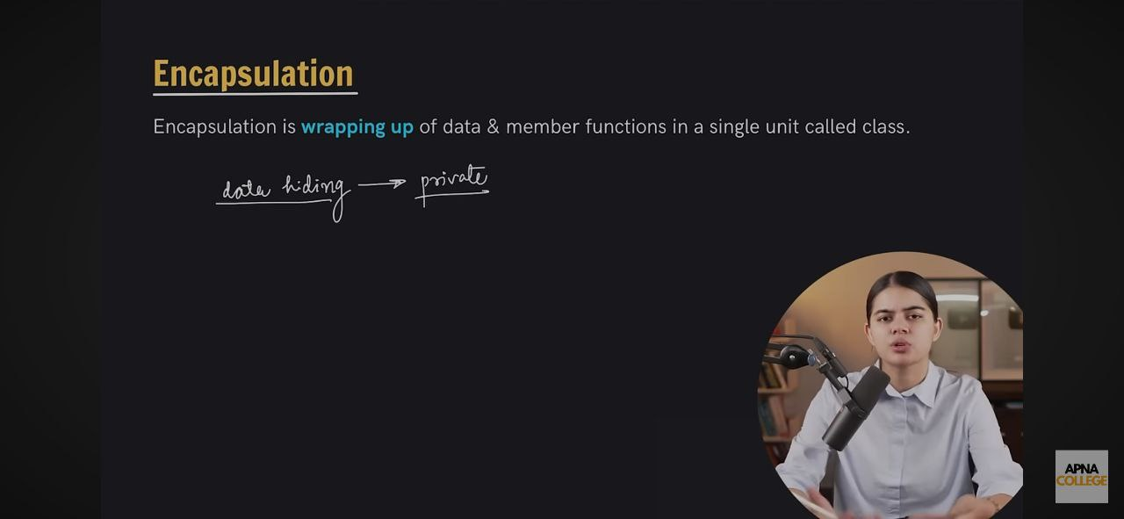

**Constractor:**

Code for Constructor OverLoading:  
#include <iostream>

using namespace std;

class Teacher{

public:

int id;

string name, dept;

double salary;

// Non parameterised constructor

Teacher(){

dept="CSE";

}

//Parameterised Constructor

/*Teacher(int i, string nam, double sal){

id = i;

name=nam;

salary = sal;

}*/

//Method for showing object data

void showdata(){

cout << dept << endl;//cout << id << " " << name << " " << dept << " " << salary << endl;

}

};

int main()

{

Teacher t1; //1, "Sayed Nahid", 1000

t1.showdata();

return 0;

}

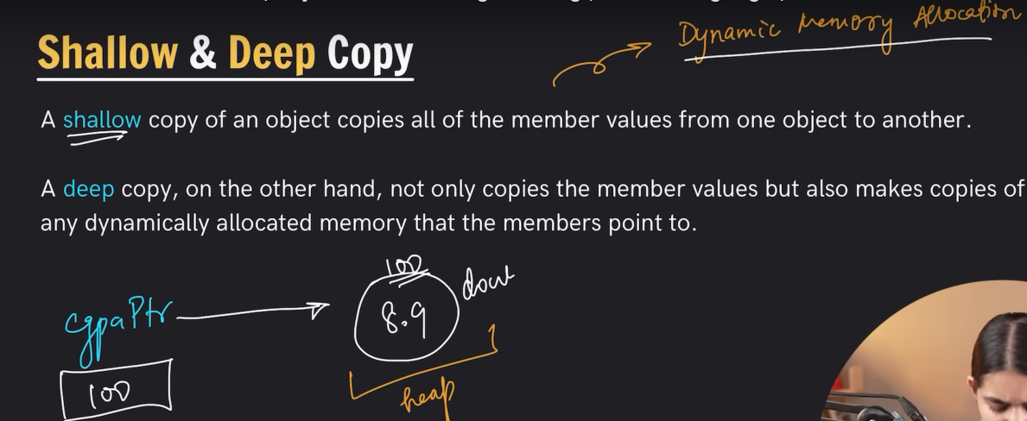

**Destructor:**

**Inheritance:**

#include <iostream>

using namespace std;

class P{

public:

string name;

P(string nam){

this->name=nam;

cout << "P C\n";

}

~P(){

cout << "P D\n";

}

};

class S: P{

public:

int age;

S(string s, int a): P(s){

this->age=a;

cout << "C C\n";

}

~S(){

cout << "C D\n";

}

void getinfo(){

cout << name << endl;

cout << age << endl;

}

};

int main()

{

S s1("Nahid", 25);

s1.getinfo();

return 0;

}

#include <iostream>

using namespace std;

class P{

public:

string name;

};

class S: public P{

public:

int roll;

};

class Gradstudent: public S{

public:

string researchArea;

};

int main()

{

Gradstudent s1;

s1.name="Nahid";

s1.roll=3849;

s1.researchArea="Machine Learning";

cout << s1.name << " " << s1.roll << " " << s1.researchArea << endl;

return 0;

}

#include <iostream>

using namespace std;

class T{

public:

int salary;

};

class S{

public:

int roll;

};

class TA: public S, public T{

};

int main()

{

TA ta1;

ta1.salary=69;

ta1.roll=3849;

cout << ta1.salary << " " << ta1.roll << endl;

return 0;

}

